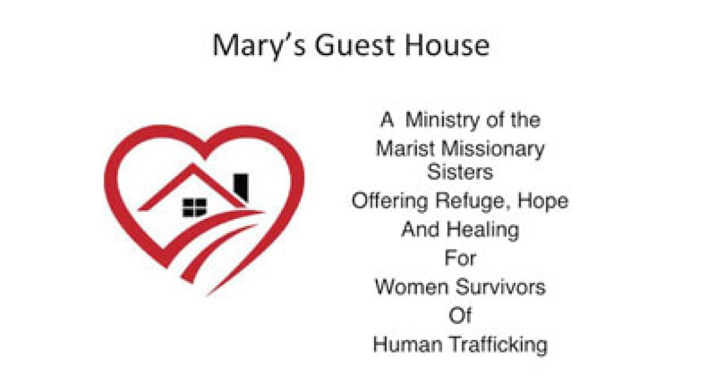
The Marist Missionary Sisters have a special concern for under-served women and children. Mary’s Guest House was born in November 2005 following in-depth research on the needs of trafficking survivors. Mary’s Guest House specifically addresses the urgent need of appropriate shelter for women survivors over the age of eighteen. Staffed full-time by two Sisters, the guest house accommodates five women.
The ultimate goal is to help the guests rebuild their lives and become self-reliant or to return to their family. The shelter provides a safe, homelike environment. Communal life is shared with the guests, accompanying them as mentors and supporting them in their struggles, hopes and dreams. Collaboration is offered with an array of services addressing their physical, medical, immigration, educational, spiritual and psychological needs. They can live at the guest house for up to two years while preparing for employment and independent living.
Another priority is to raise awareness to Human Trafficking through speaking engagements and presentations as active collaborators in the San Diego Network Against Trafficking to combat exploitation locally and globally.
P.O. Box 121828
Chula Vista, CA 91912

